Blessings for the holiday of Rosh Hashanah
Candles
בָּרוּךְ אַתָּה אַדֹנָ-י אֱ-לֹהֵינוּ מֶלֶךְ הָעוֹלָם אֲשֶׁר קִדְּשָׁנוּ בְּמִצְוֹתָיו וְצִוָּנוּ לְהַדְלִיק נֵר שֶׁל יום חול.
Transliteration: Baruch A-tah Ado-nai E-lo-hei-nu Me-lech Ha-olam A-sher Ki-de-sha-nu Be-mitz-vo-tav Ve-tzi-va-nu Le-had-lik Ner Shel Yom Chol.
Translation: Blessed are You, Lord our G-d, King of the universe, who has sanctified us with His commandments, and commanded us to kindle the light of the holiday.

The Shehecheyonu blessing:
After reciting the holiday candle-lighting blessing, the Shehecheyanu blessing is recited, thanking G-d for giving us the life and strength to reach this special day.
בָּרוּךְ אַתָּה אַדֹנָ-י אֱ-לֹהֵינוּ מֶלֶךְ הָעוֹלָם שהחיינו וקיימנו והגיענו לזמן הזה.

Transliteration: Bo-ruch a-toh Ado-noi E-lo-hei-nu me-lech ho-olom she-he-che-ya-nu vi-kee-yi-ma-nu vi-hi-gee-an-u liz-man ha-zeh.
Translation: Blessed are you, L-rd our G-d, King of the universe, who has kept us alive and sustained us and let us reach this time.

Blessing for the Wine (Kiddush)
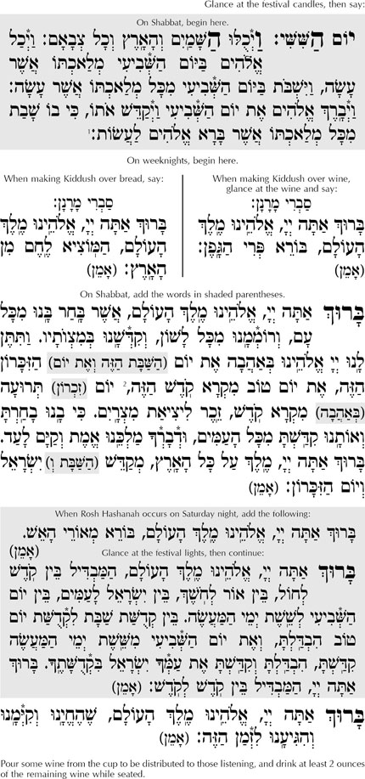
Washing hands
We wash our hands and say:
בָּרוּךְ אַתָּה יְהוָה אֱלֹהֵינוּ מֶלֶךְ הָעוֹלָם, אֲשֶׁר קִדְּשָׁנוּ בְּמִצְווֹתָיו, וְצִוָּנוּ עַל נְטִילַת יָדָיִם
Transliteration: Ba-ruch a-tah Ad-onai, E-lo-hei-nu me-lech ha-olam, a-sher ki-desh-an-u be-mitz-vo-tav ve-tziv-anu al ne-til-at ya-da-yim.
Translation: Blessed are you, L-rd our G-d, King of the universe, who has sanctified us with His commandments, and commanded us concerning the washing of the hands.
Round Challah
When everyone has returned to the table, we raise the two challahloaves and recite the Hamotzie blessing:
ברוך אתה ה' אלוהינו מלך העולם המוציא לחם מן הארץ
Transliteration: Ba-ruch atah A-do-nai, E-lo-hei-nu Melech Ha-Olam, hamotzie le-chem min ha-ar-etz.
Translation: Blessed are You, L-rd, our G-d, King of the universe, who brings forth bread from the earth.
Cut the challah, dip it in honey and pass around pieces and make sure everyone does the same.

רימון - Pomegranate
Take the pomegranate and say:
יְהִי רָצוֹן מִלְּפָנֶיךָ ה' אֱלֹהינוּ וֵאלֵֹהי אֲבוֹתֵינוּ, שֶׁנִּהְיֶה מְלֵאִים מִצְוֹת כָּרִמּוֹן
Transliteration: Yeh-hi Ra-tzon Mil-fa-neh-cha Adonai eloeynu ielohei avotenu sheh-nih-yeh meh-leh-im mitz-vot ka-ri-mon.
Translation: May it be Your will, Lord our G-d and the G-d of our fathers, that we be filled with mitzvot like a pomegranate [is filled with seeds].
תפוח בדבש - Apple and Honey
Dip an apple in honey – some have the custom of using an apple cooked with sugar – and say:
יְהִי רָצוֹן מִלְּפָנֶיךָ ה' אֱלֹהינוּ וֵאלֵֹהי אֲבוֹתֵינוּ, שֶׁתְּחַדֵּשׁ עָלֵינוּ שָׁנָה טוֹבָה וּמְתוּקָה כַּדְּבָשׁ
Transliteration: Yeh-hi Ra-tzon Mil-fa-neh-cha Adonai eloeynu ielohei avotenu sheh-the-cha-desh a-lehy-nu shana Tova u-meh-tu-kah.
Translation: May it be Your will, Lord our G-d and the G-d of our fathers, that You renew for us a year good and sweet like honey.
ראש דג - Fish's Head
יְהִי רָצוֹן מִלְּפָנֶיךָ ה' אֱלֹהינוּ וֵאלֵֹהי אֲבוֹתֵינוּ, שֶׁנִּהְיֶה לְרֹאשׁ וְלֹא לְזָנָב
Transliteration: Yeh-hi Ra-tzon Mil-fa-neh-cha Adonai eloeynu ielohei avotenu sheh-neh-yeh leh-rosh veh-o leh-za-nav.
Translation: May it be Your will, Lord our G-d and the G-d of our fathers, that we be a head and not a tail.

